TALEND-

* + Chinook (MySQL) to Chinook_DW (SQL Server)

1. DIMARTIST

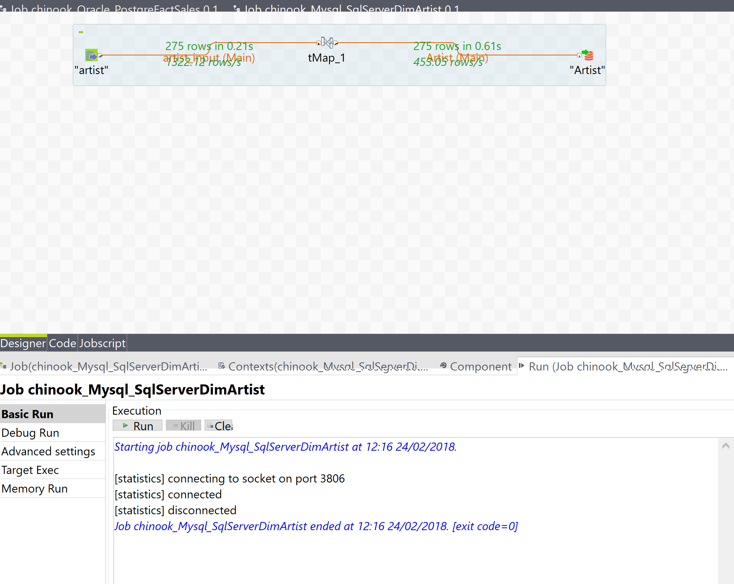

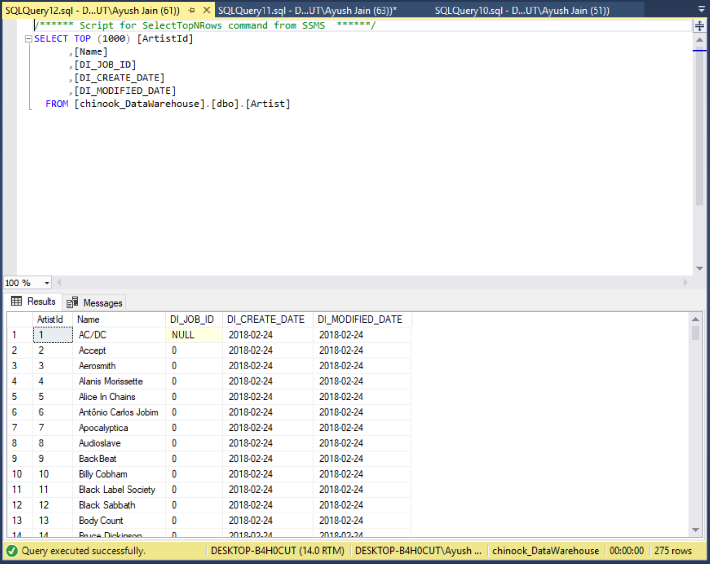

* + Table name-DIMARTIST
  + Row Count-275
  + DI_Job_ID-0
  + Max(DI_Created_Date)-2018-02-24
  + Current_User (of this query)-DESKTOP-B4H0CUT\Ayush
  + Current_Timestamp (of query)-2018-02-24 12:16pm
  + Root Process Id: 5oPpiQ

2)DIMCOMPOSER

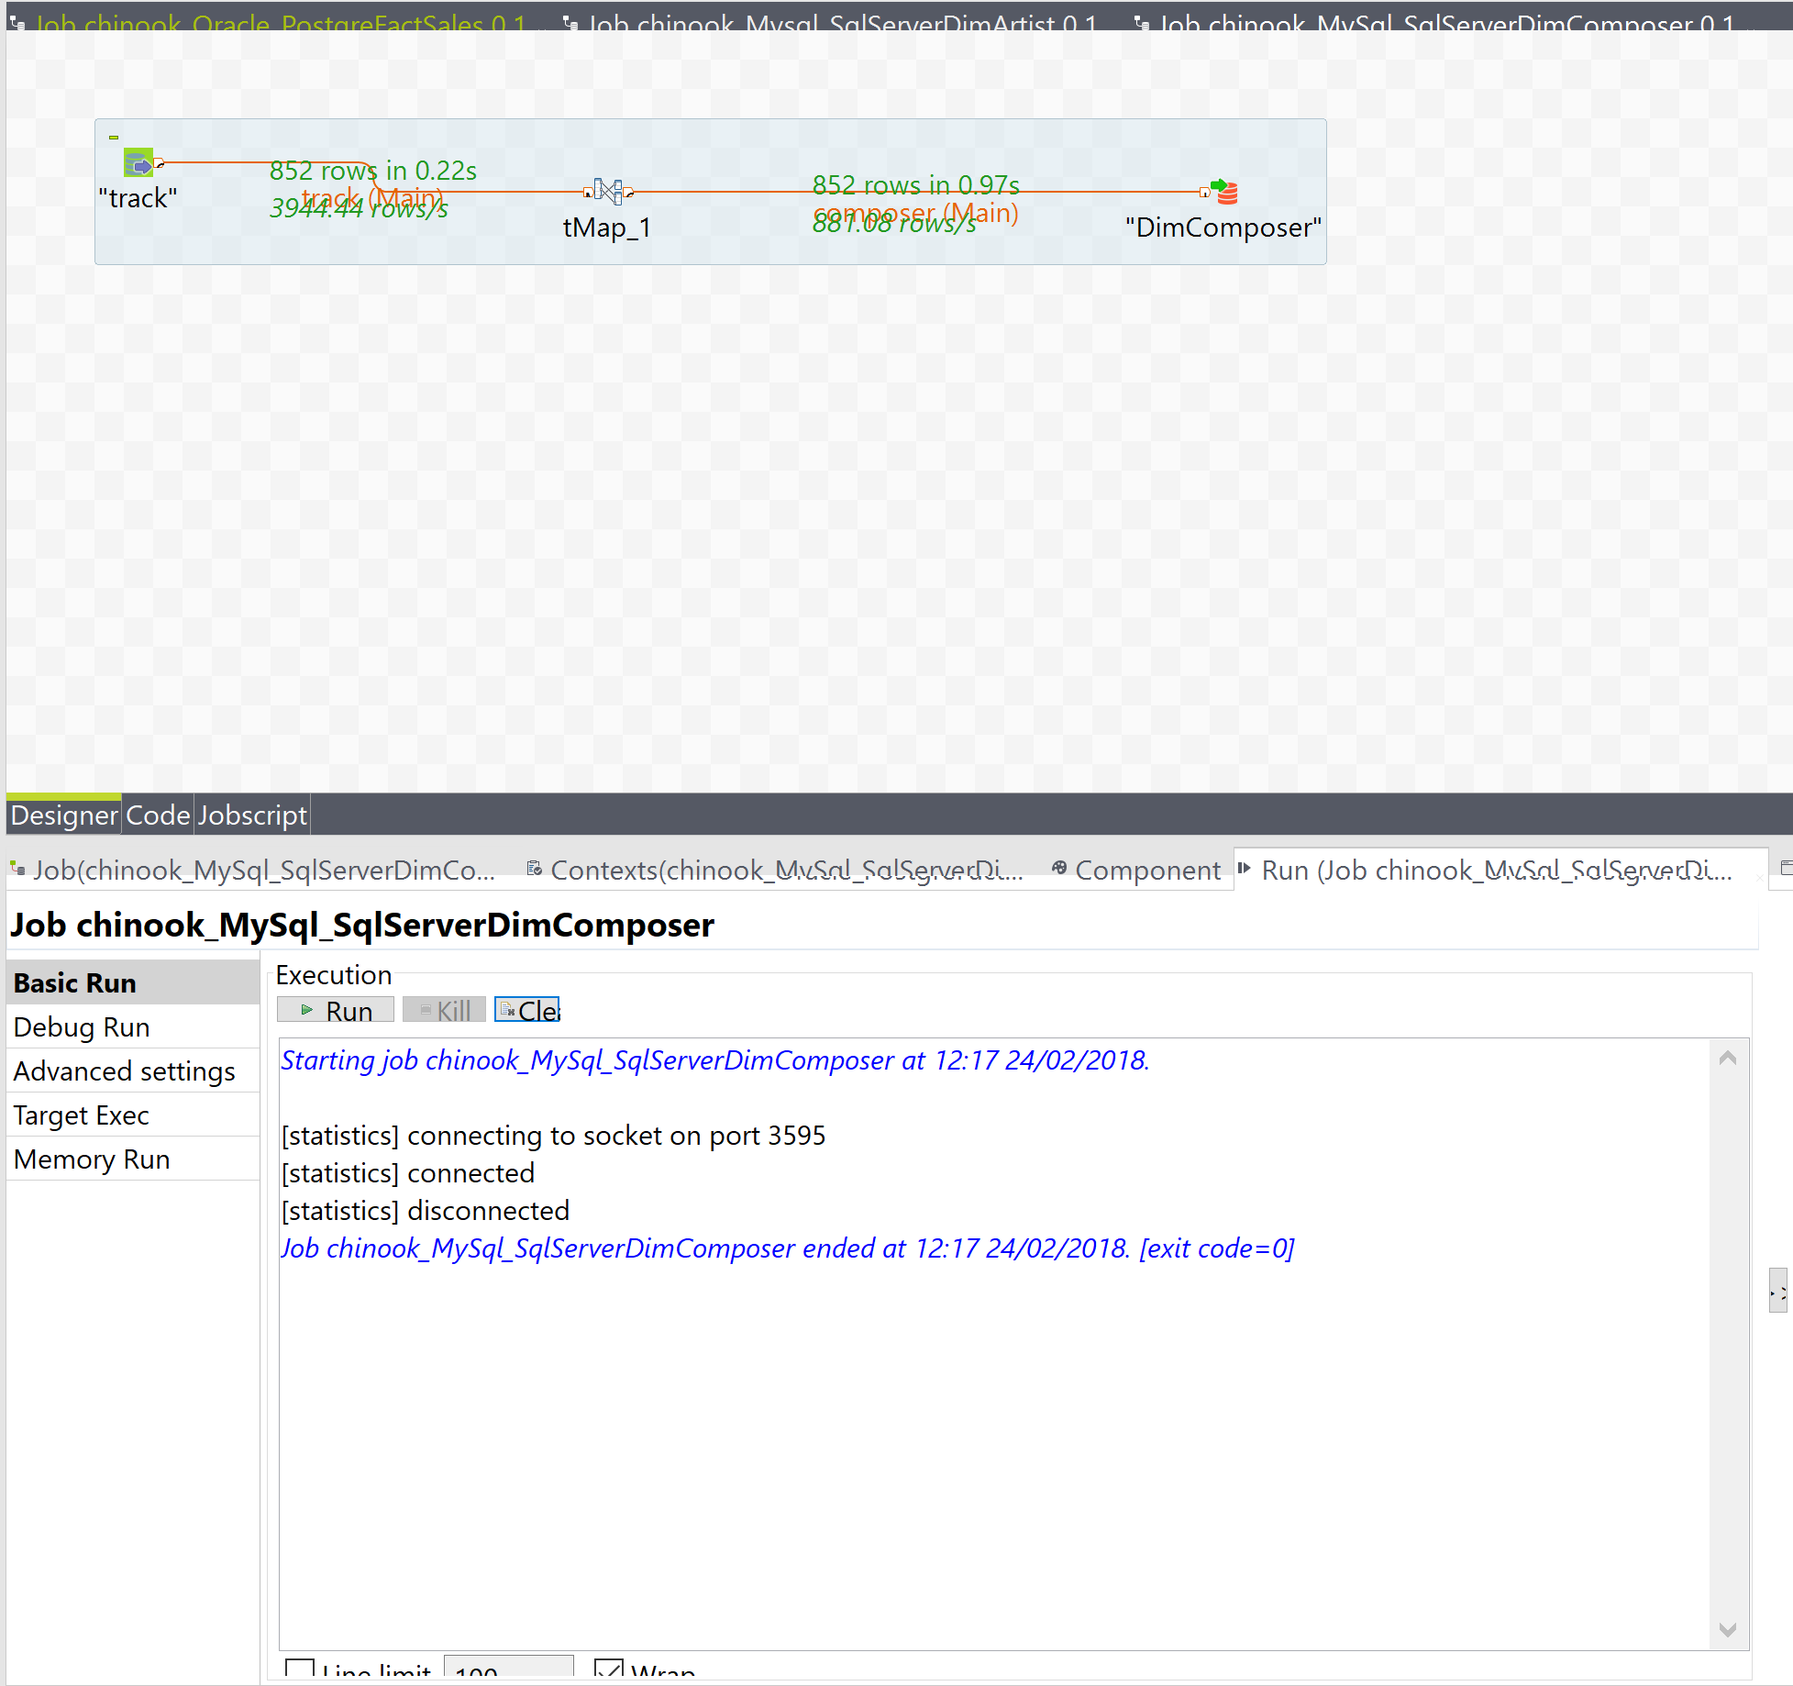

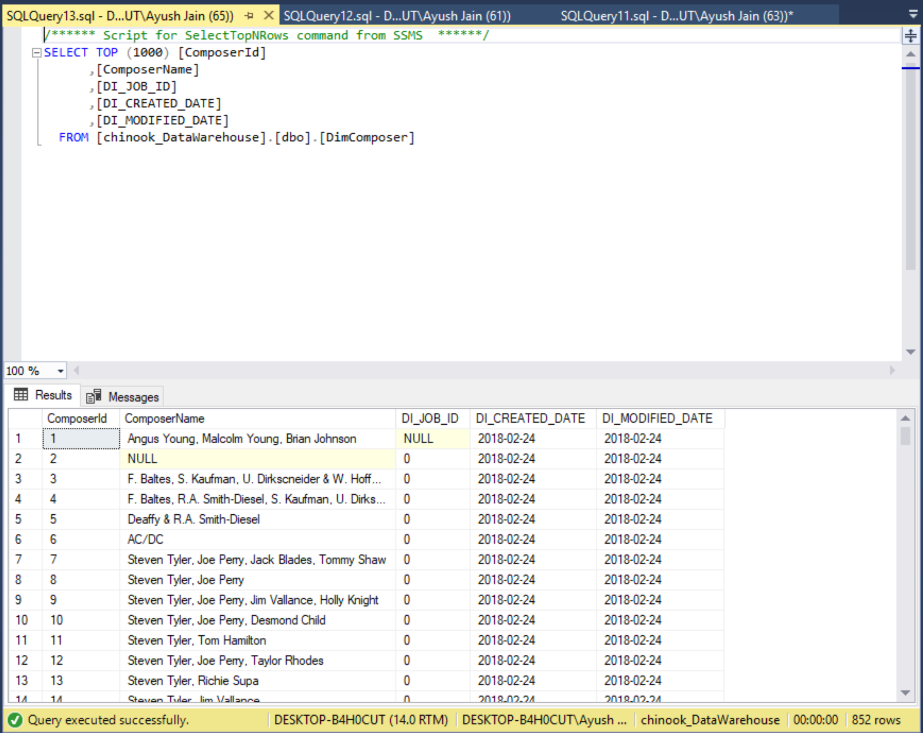

* + Table name-DimComposer
  + Row Count-852
  + DI_Job_ID-0
  + Max(DI_Created_Date)-2018-02-24
  + Current_User (of this query)-DESKTOP_B4H0CUT\Ayush
  + Current_Timestamp (of query) 24-02-2018 12:17pm
  + Root Process ID: fiLeYo

3)DIMGEOGRAPHY

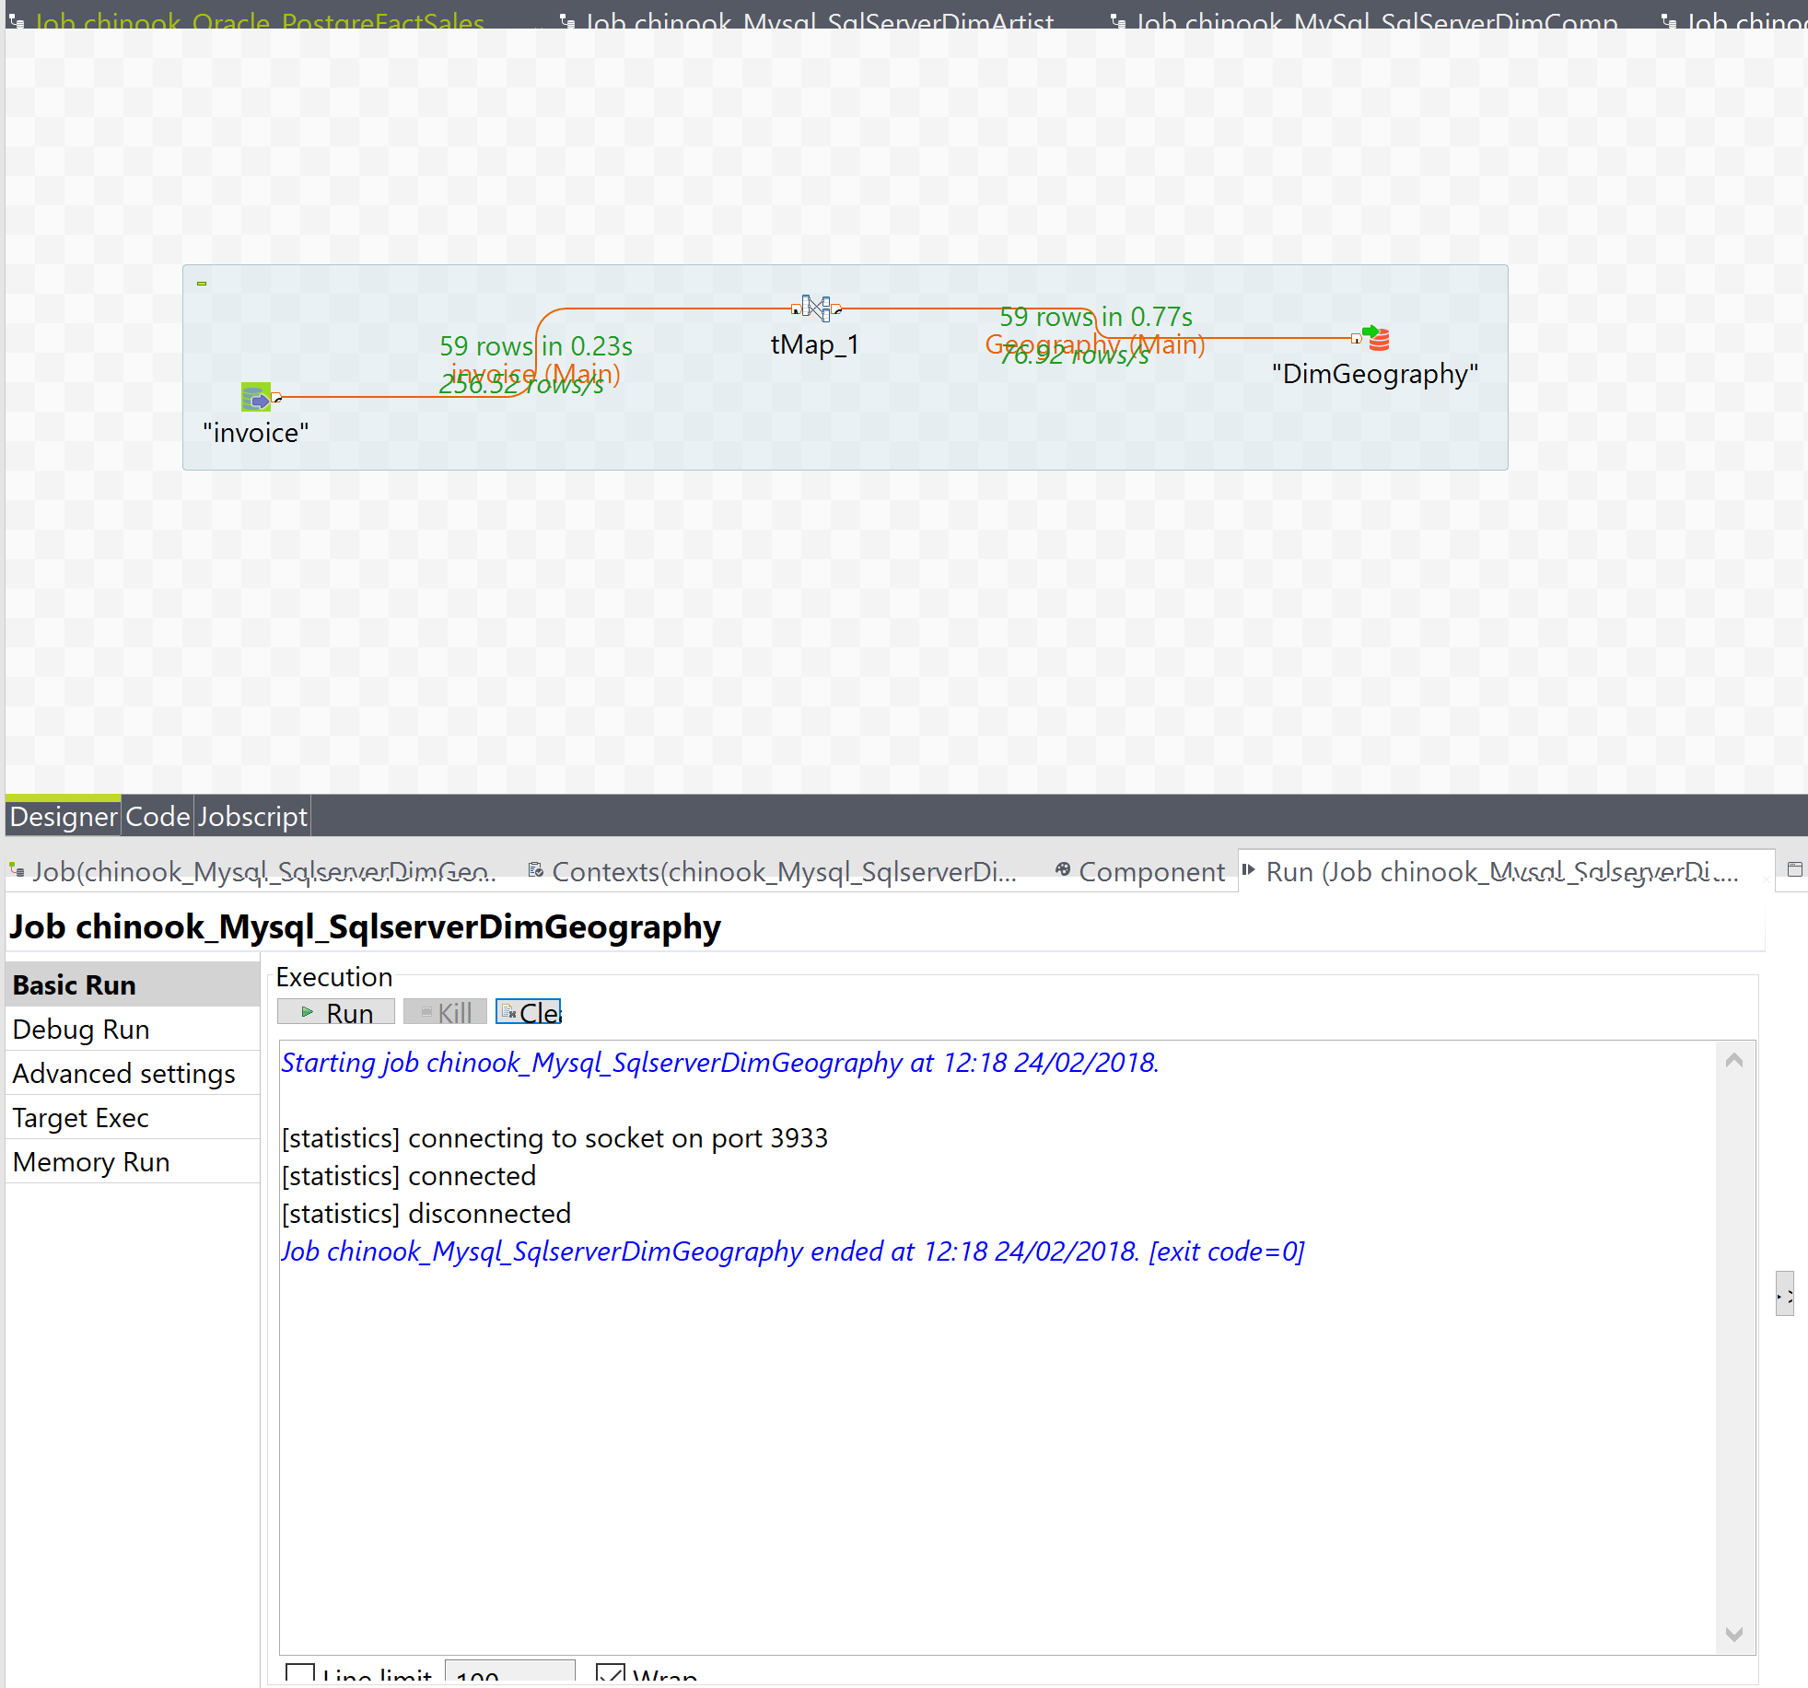

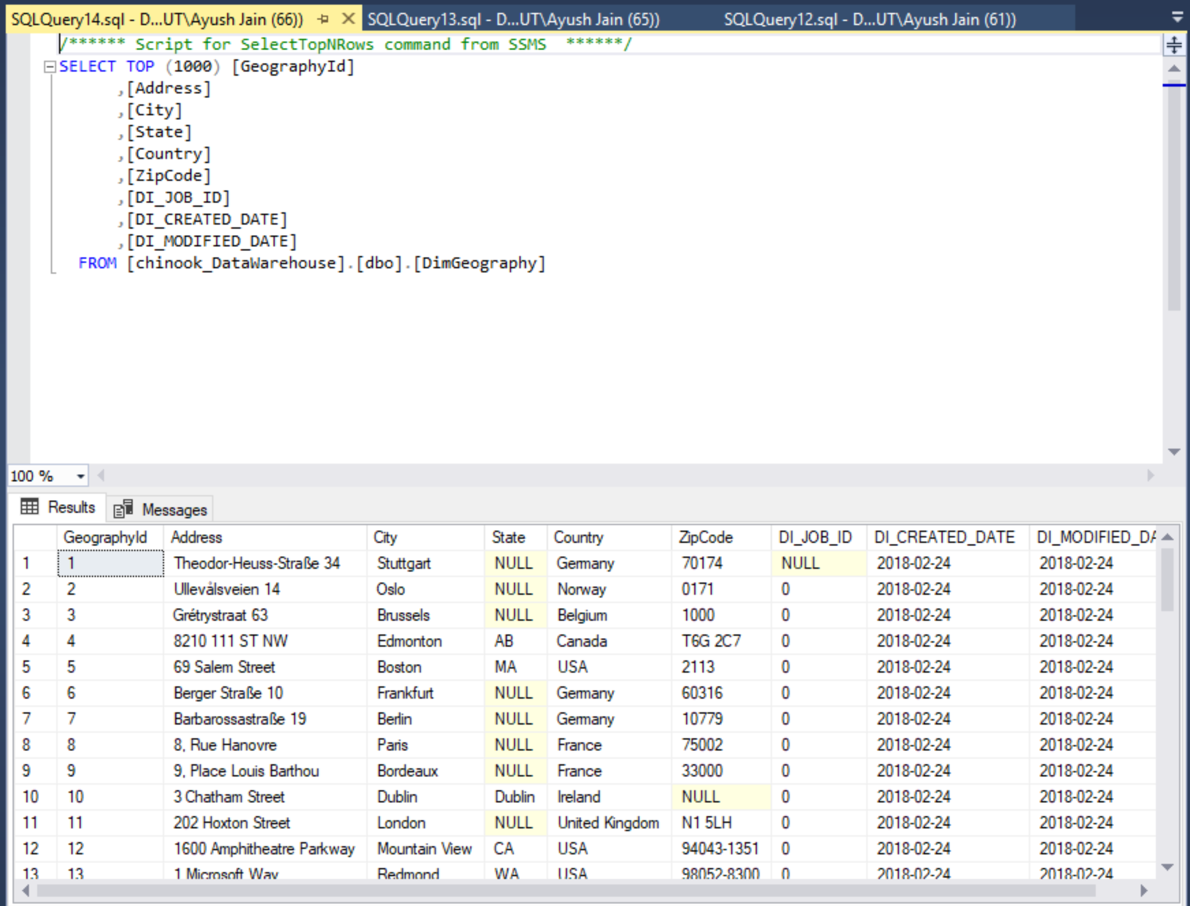

* + Table name-DimGeography
  + Row Count-59
  + DI_Job_ID-0
  + Max(DI_Created_Date)-2018-02-24
  + Current_User (of this query)-DESKTOP_B4H0CUT\Ayush
  + Current_Timestamp (of query)-24/02/2018 12:18pm
  + Root Process Id: YXPGF7

4)DIMCUSTOMER

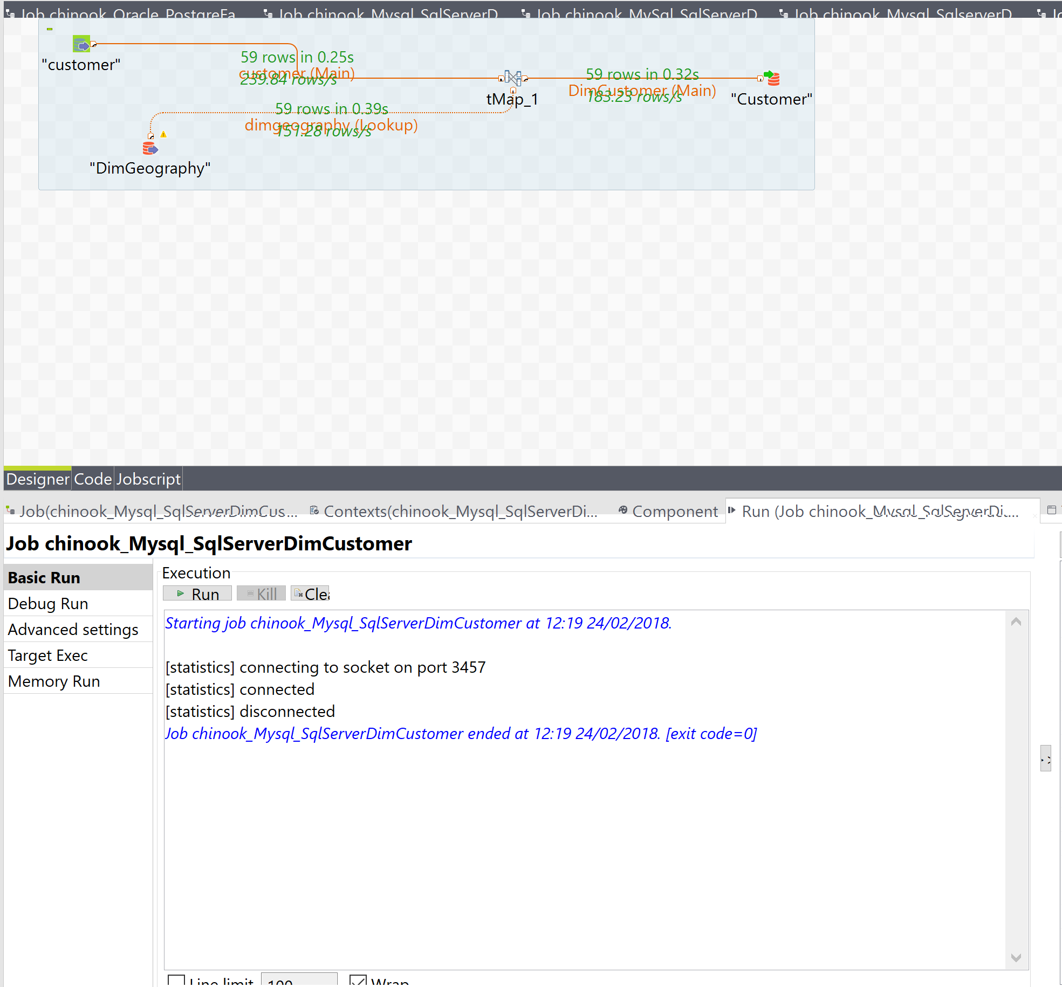

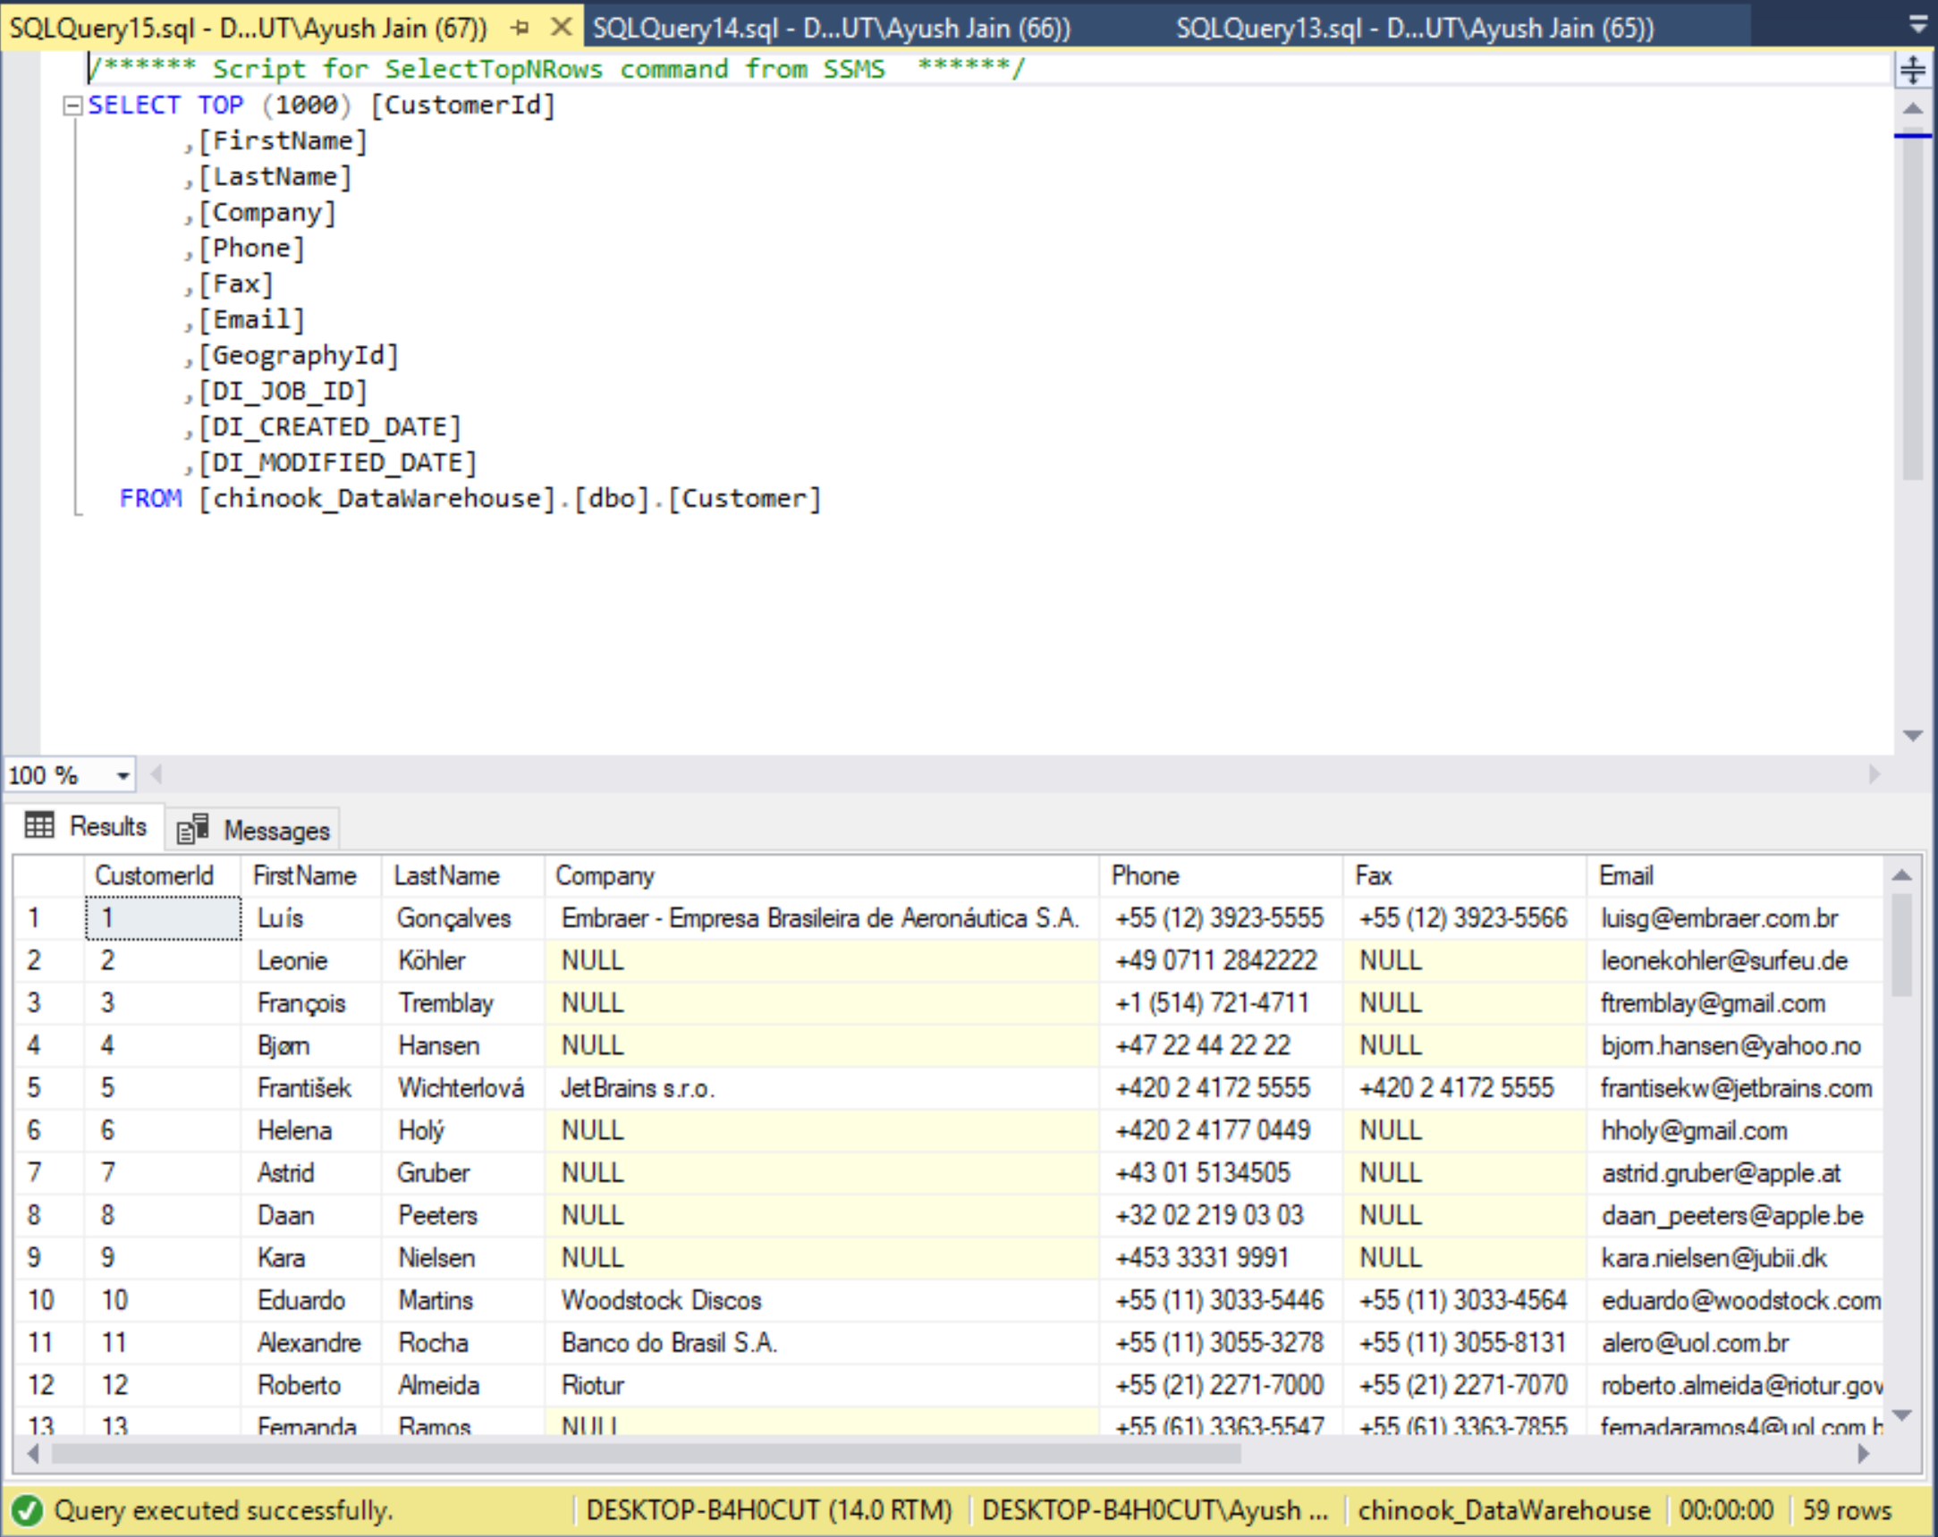

* + Table name-DimCustomer
  + Row Count-59
  + DI_Job_ID-0
  + Max(DI_Created_Date)-24/02/2018
  + Current_User (of this query)-DESKYOP-B4H0CUT\Ayush
  + Current_Timestamp (of query)-24-02-2018 12:19 pm
  + Root Process Id: JEjhgB

5)DIMDATE

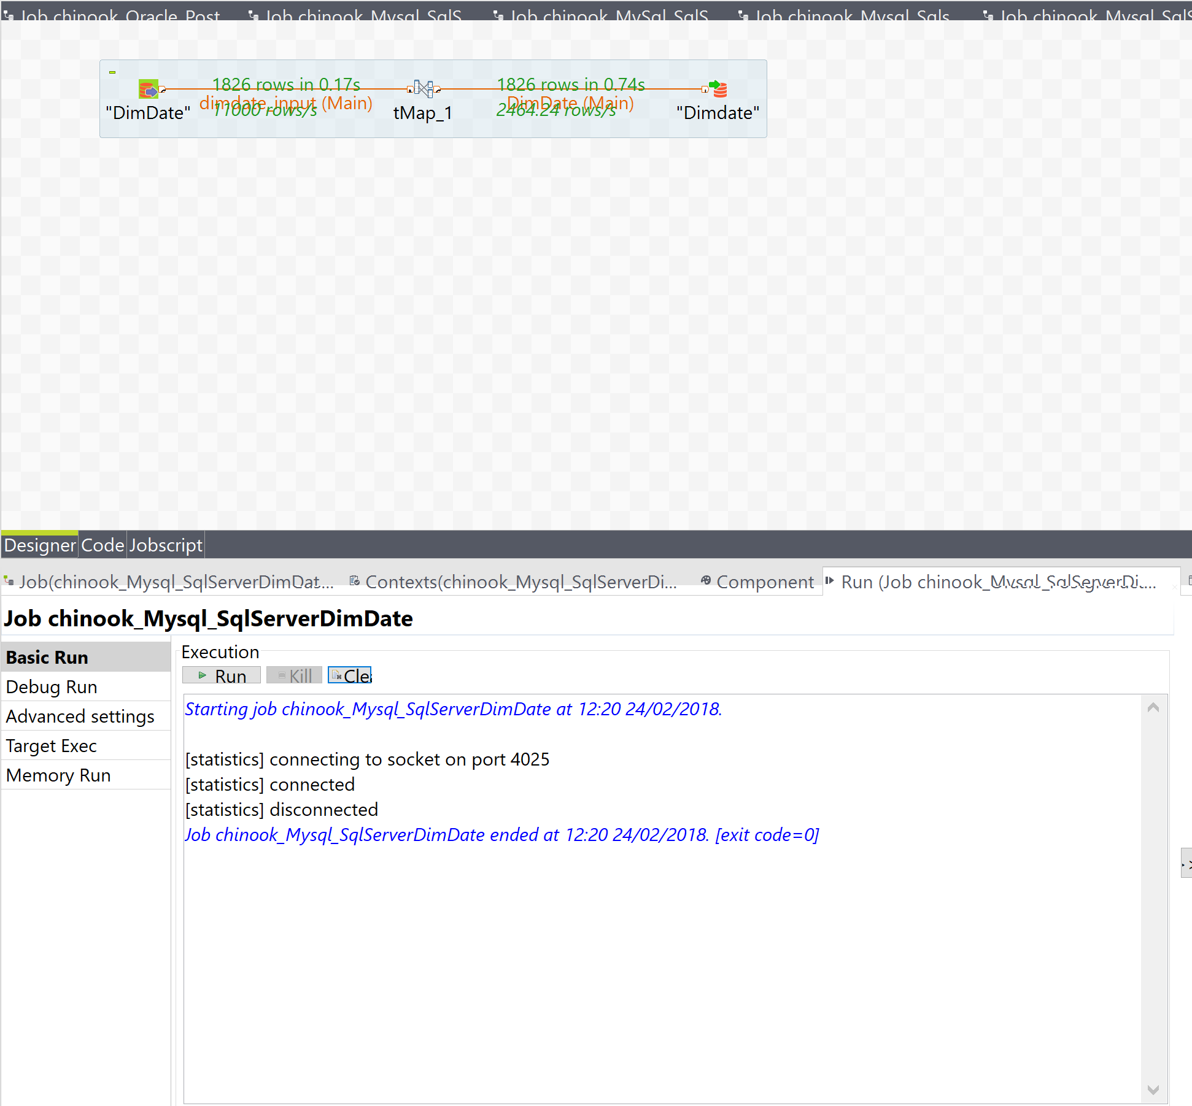

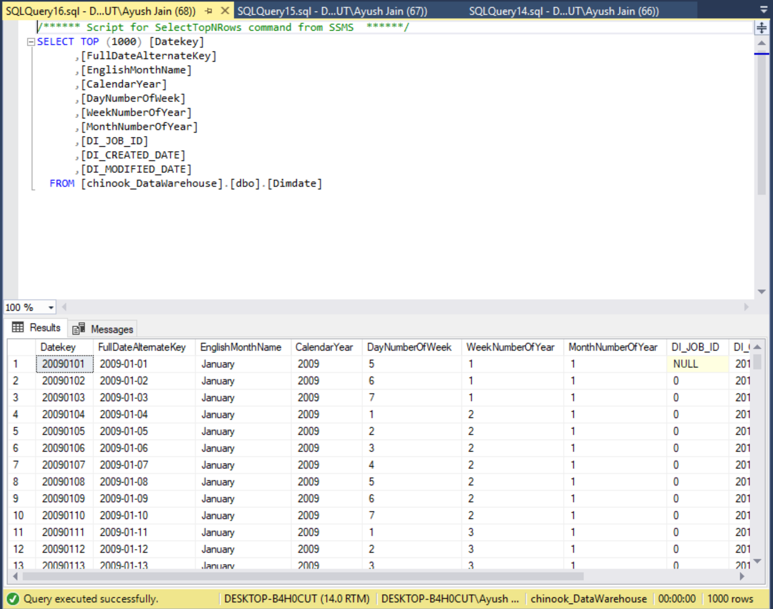

* + Table name-DimDate
  + Row Count-1826
  + DI_Job_ID-0
  + Max(DI_Created_Date)-24/02/2018
  + Current_User (of this query)-DESKTOP-B4H0CUT/Ayush
  + Current_Timestamp (of query)-24/02/2018 12:20
  + Root Process Id- JEjhgB

6)DIMPLAYLIST

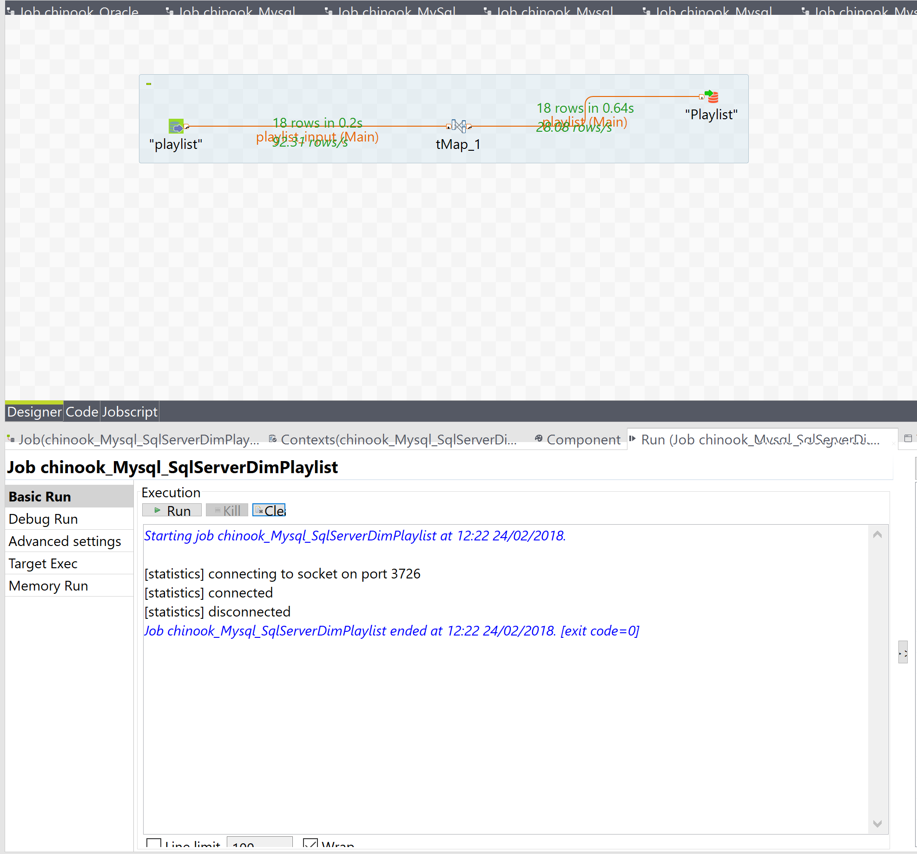

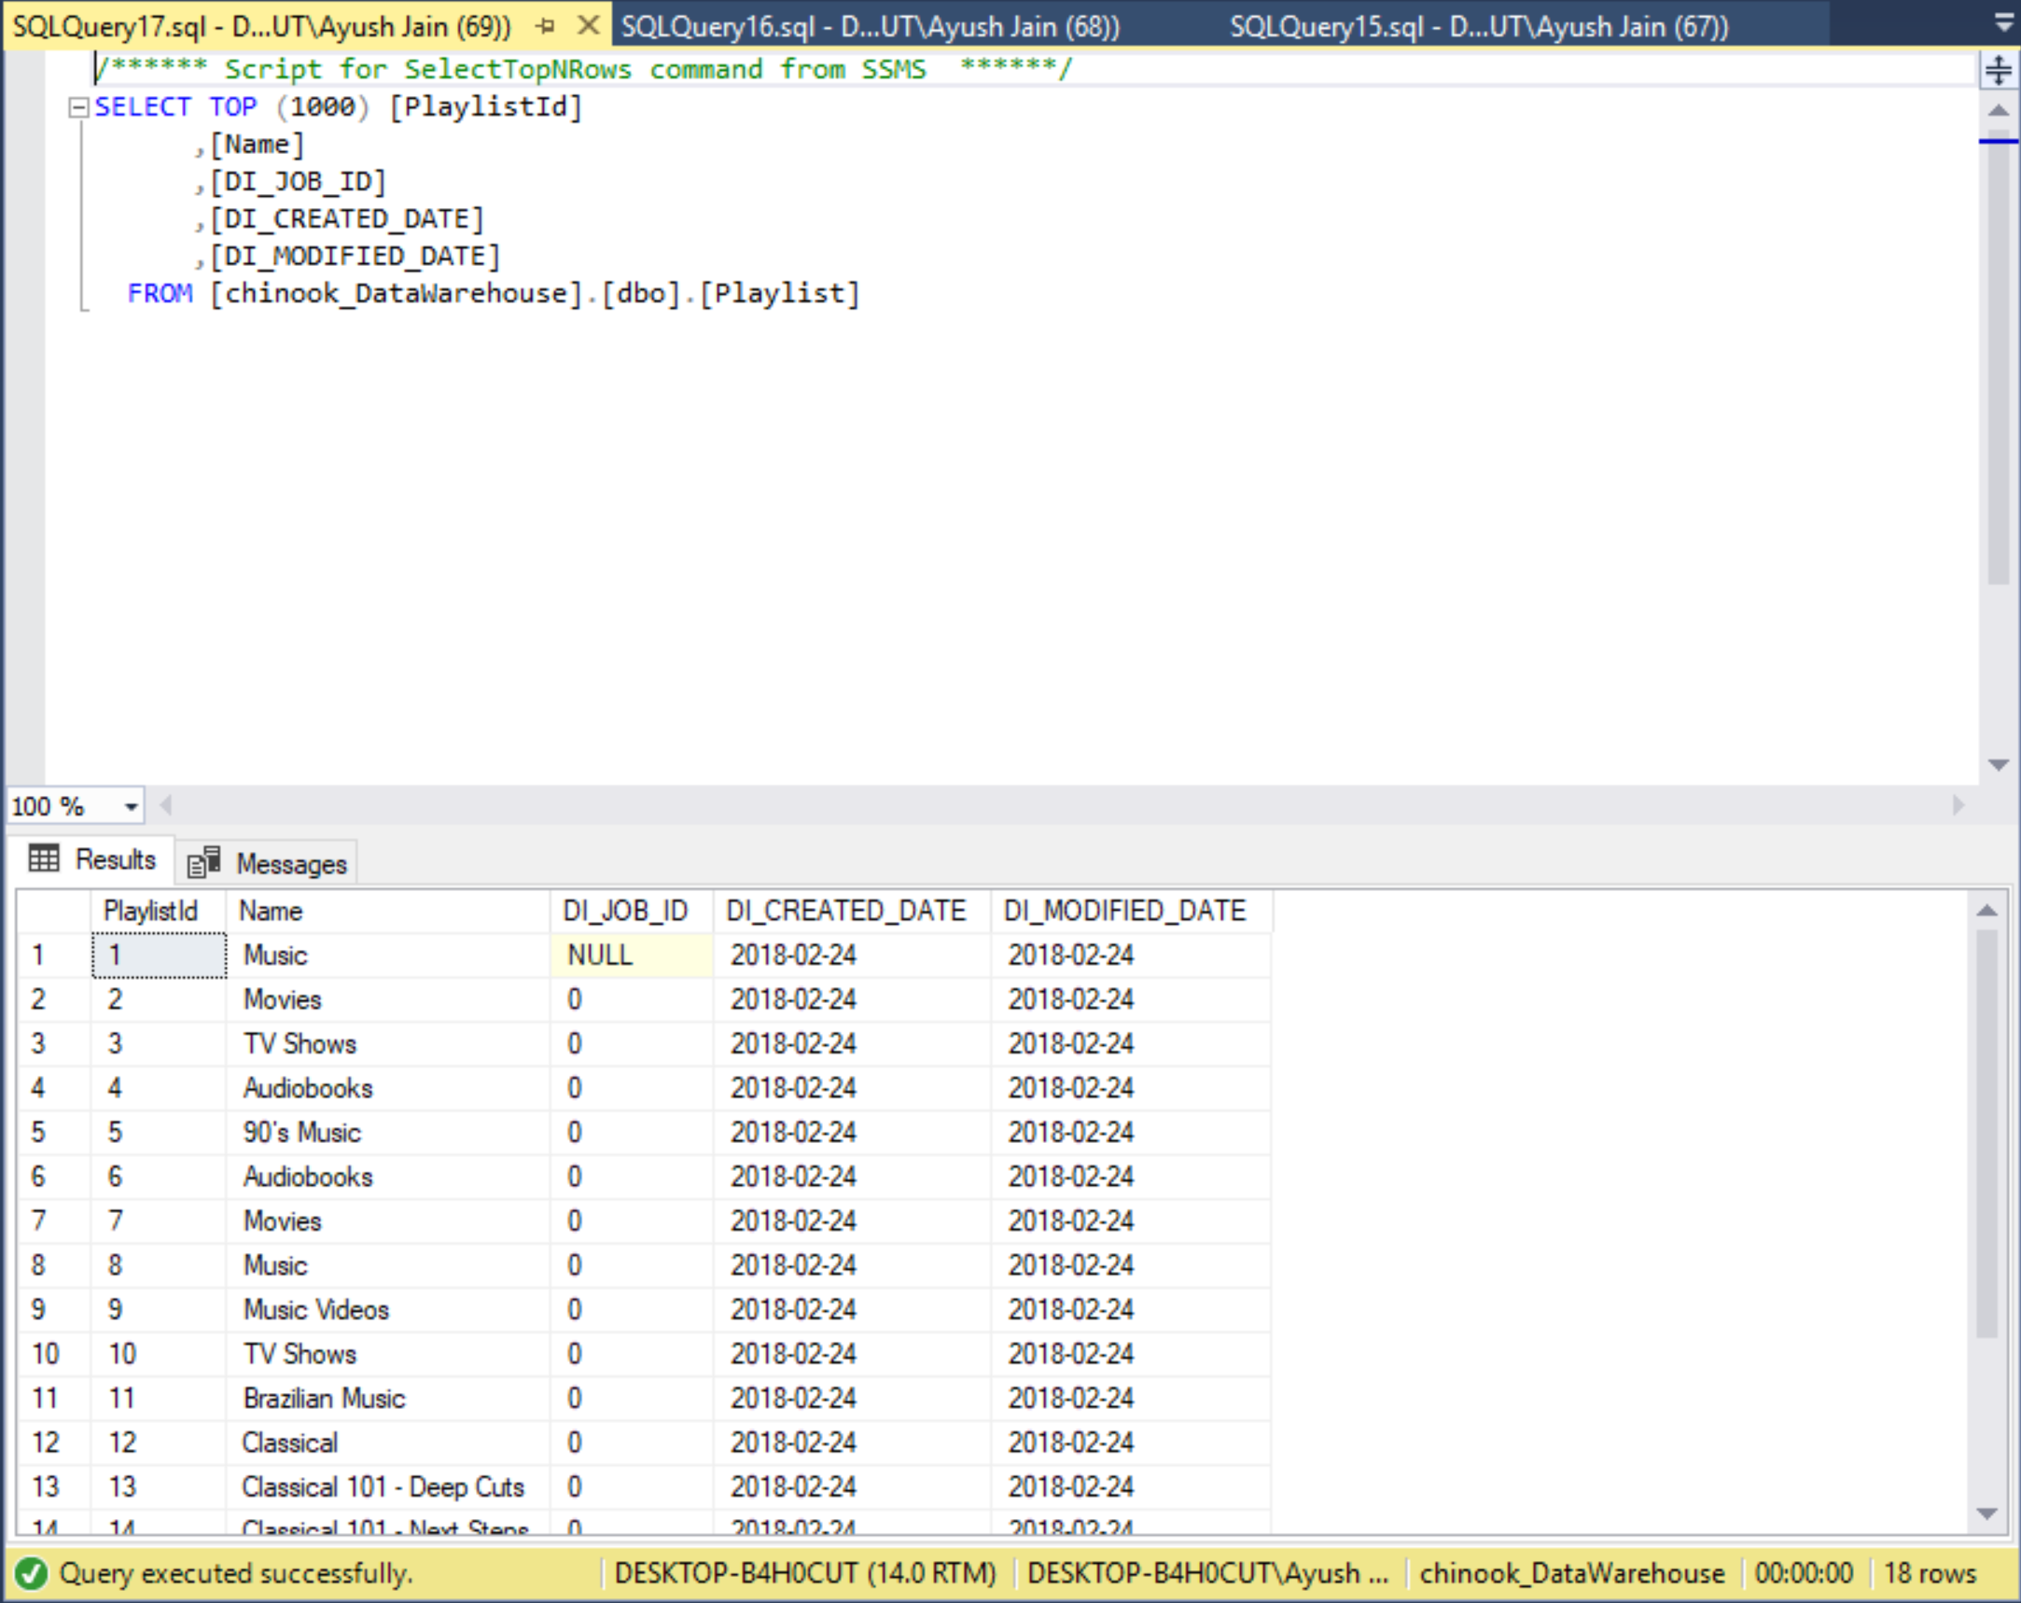

* + Table name-DIMPLAYLIST
  + Row Count-18
  + DI_Job_ID-0
  + Max(DI_Created_Date)-2018-02-24
  + Current_User (of this query)-DESKTOP-B4H0CUT/Ayush
  + Current_Timestamp (of query)-24-02-2018 12:24pm
  + Root Process Id- apXnYe

7)DIMSONGS

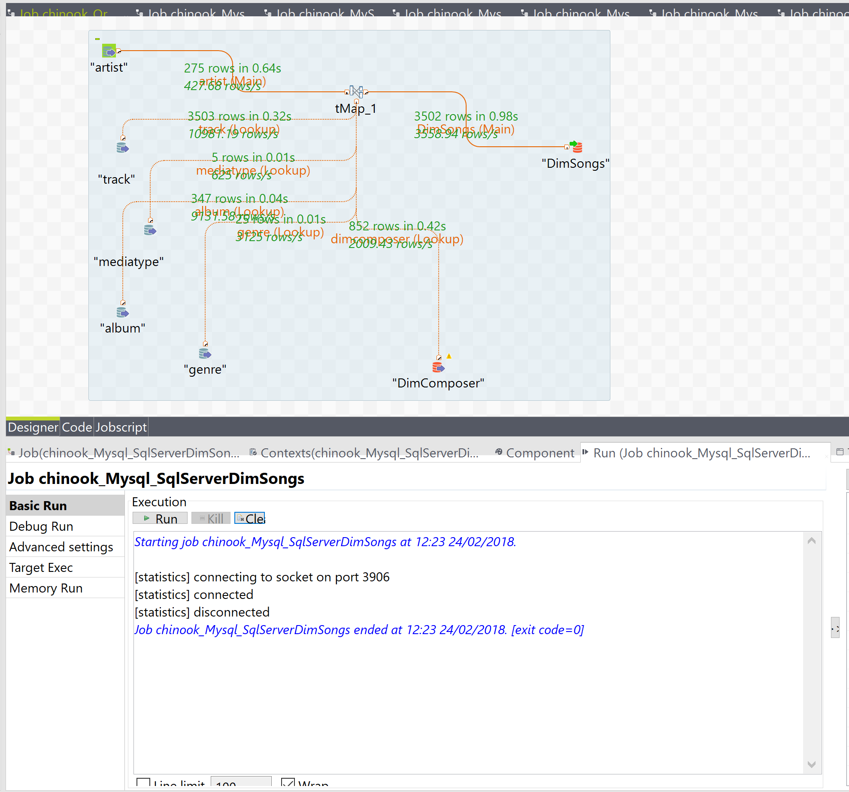

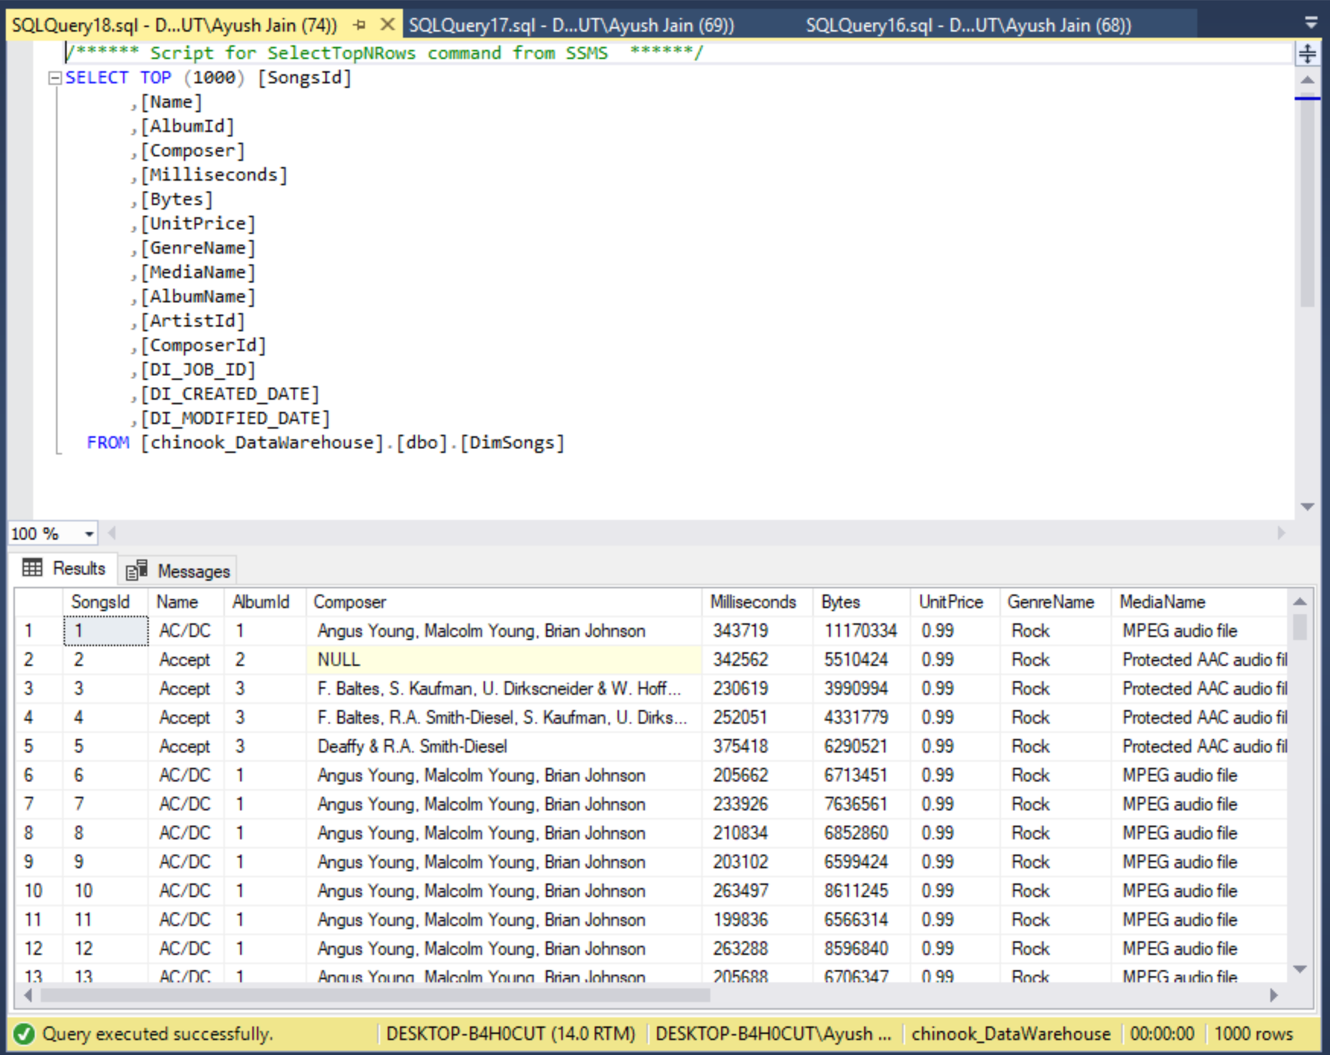

* + Table name-DimSongs
  + Row Count-3502
  + DI_Job_ID-0
  + Max(DI_Created_Date)-2018-02-24
  + Current_User (of this query)-DESKTOP-B4H0CUT\Ayush
  + Current_Timestamp (of query)-2018-02-24 12:23pm
  + Root Process ID: 48o4bi

8)FACTSALES

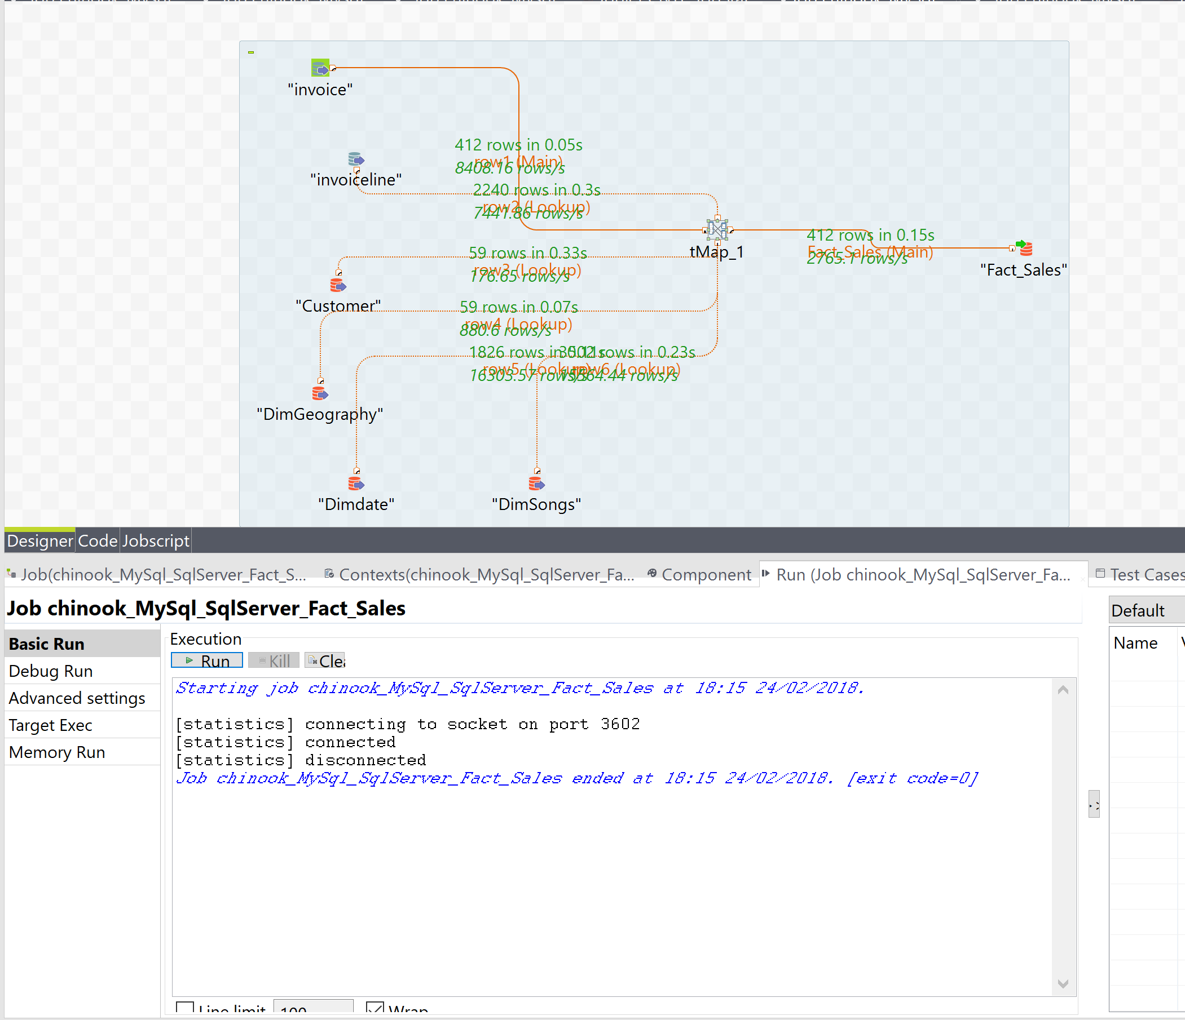

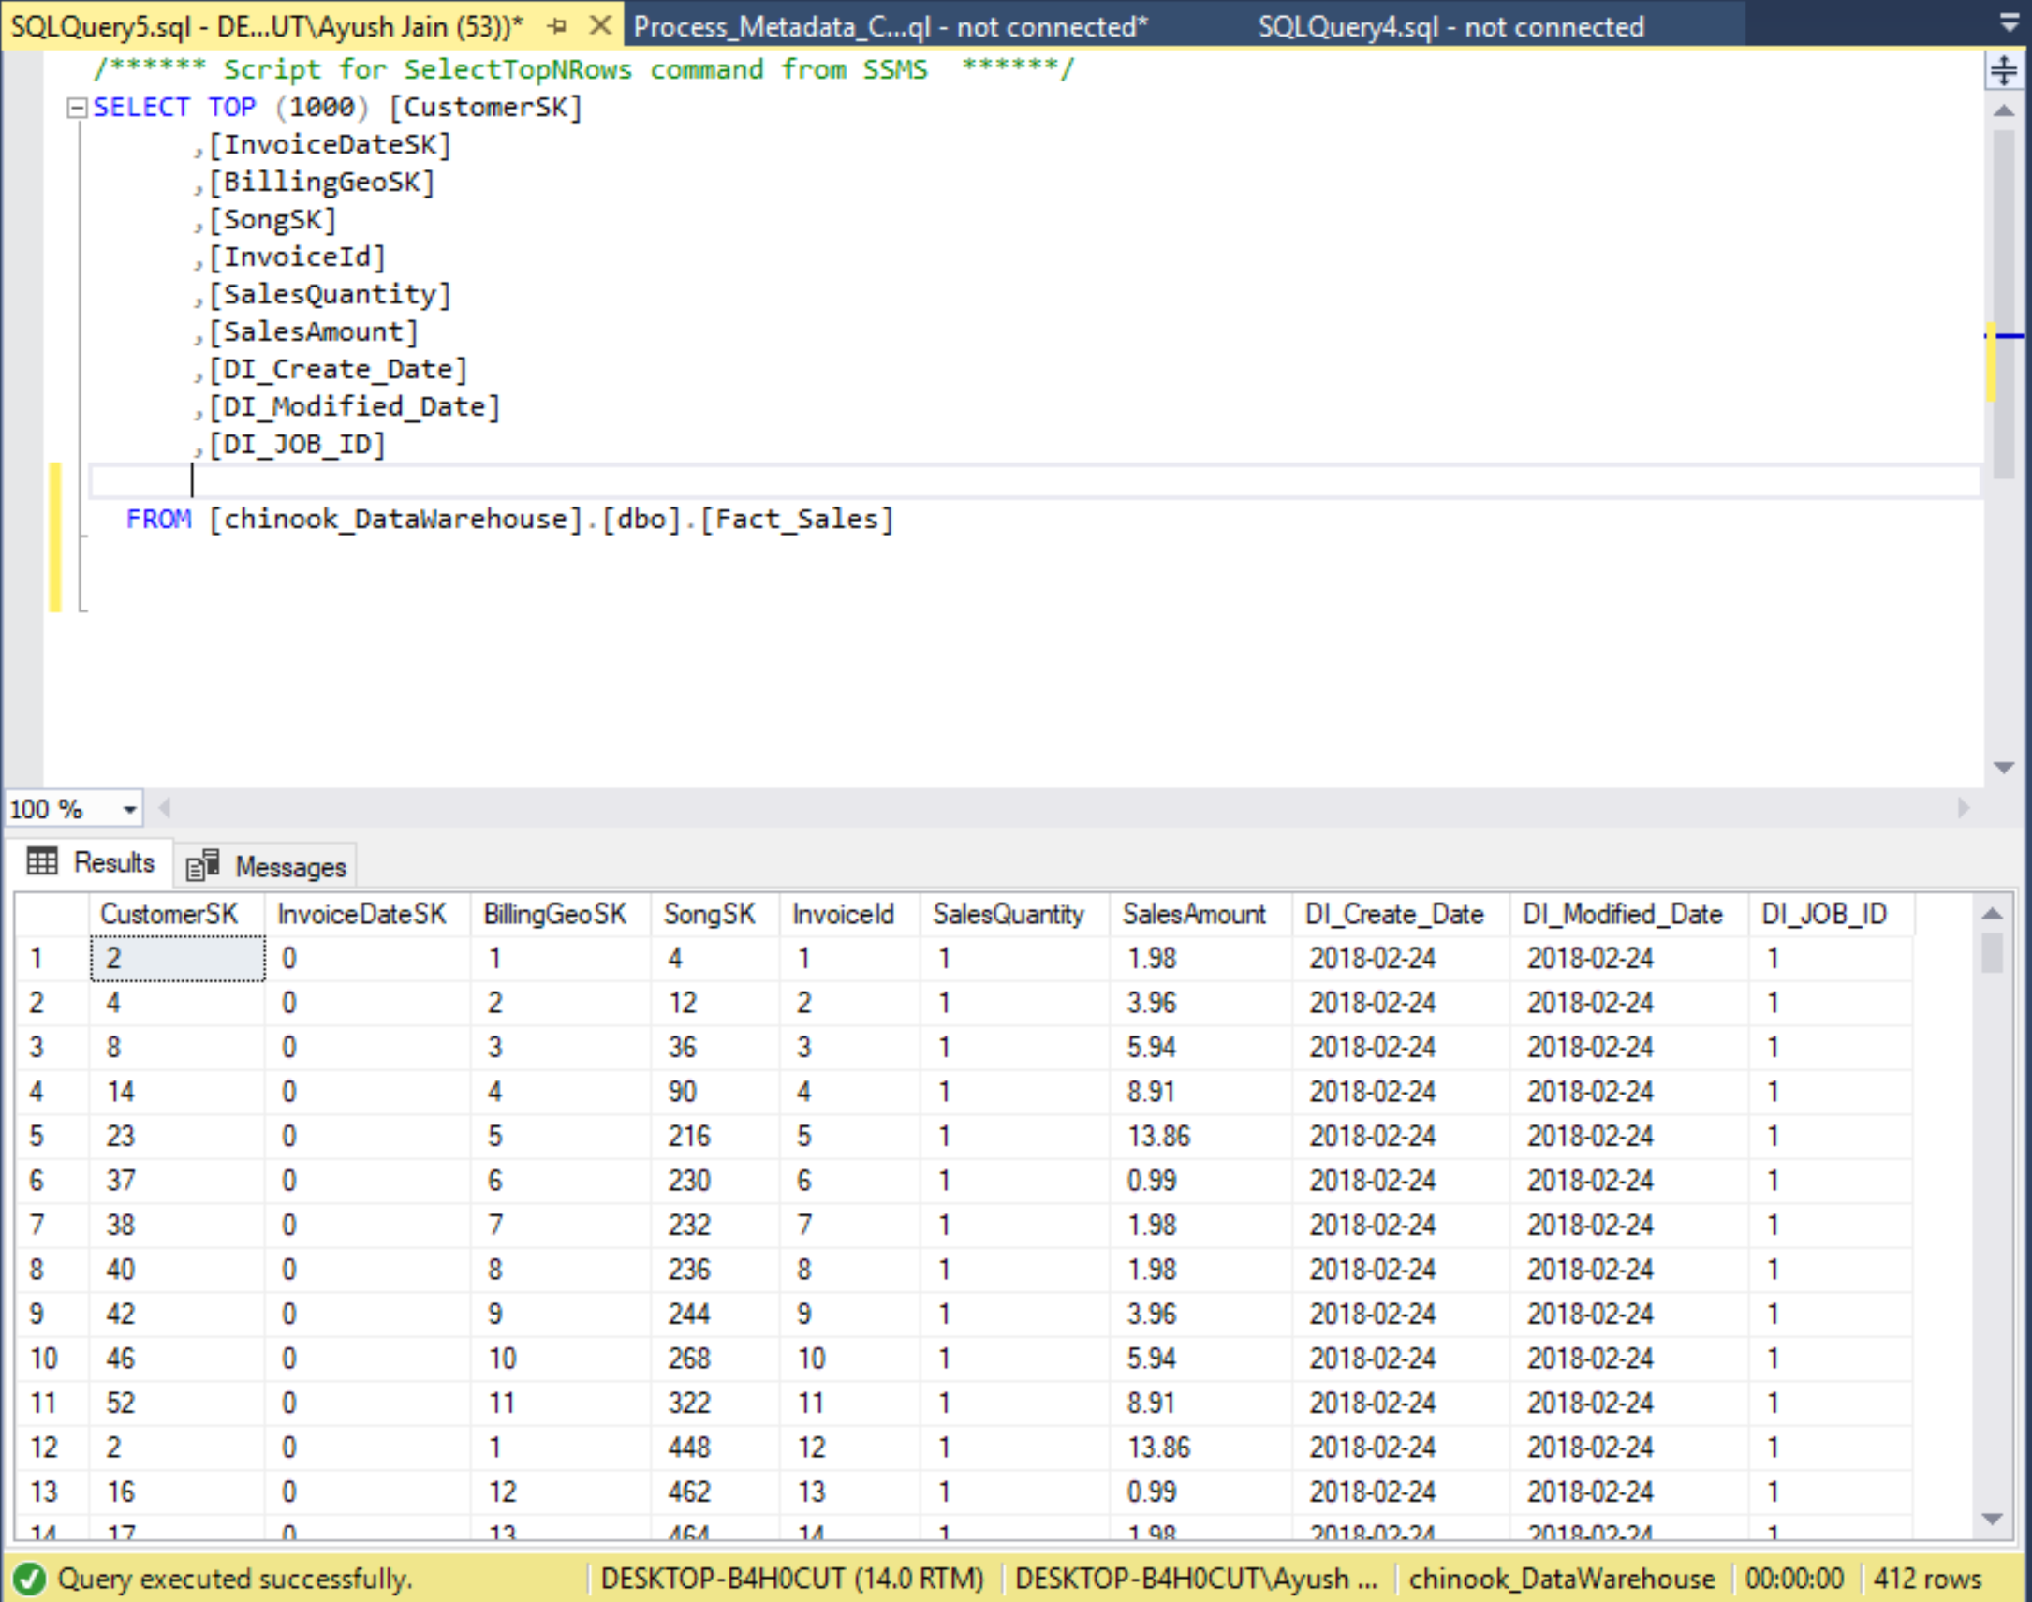

* + Table name-FactSales
  + Row Count-412
  + DI_Job_ID-1
  + Max(DI_Created_Date)-2018-02-24
  + Current_User (of this query)-DESKTOP-B4H0CUT\Ayush
  + Current_Timestamp (of query)-2018-02-24 18:15
  + Root Process Id : 7PUJXK